Project 1: Interpret Data Visualization – Malaria in Africa

Observation: The correlation between a number of deaths due to malaria in Algeria, Niger, Kenya and GPD per capita (in US$) in this countries.

GPD per capita is a measure of a country's economic output that takes the gross domestic product (GDP) and divides by its total population.

Insight 1:
Clicking on Algeria on the map displays us that Algeria has 1 average death due to malaria for each year from 2000 and 2014. This data is the lowest average index in the given data. GPD per capita in Algeria incresed from 2000 year and equl to 5,466 $ in 2014 year.

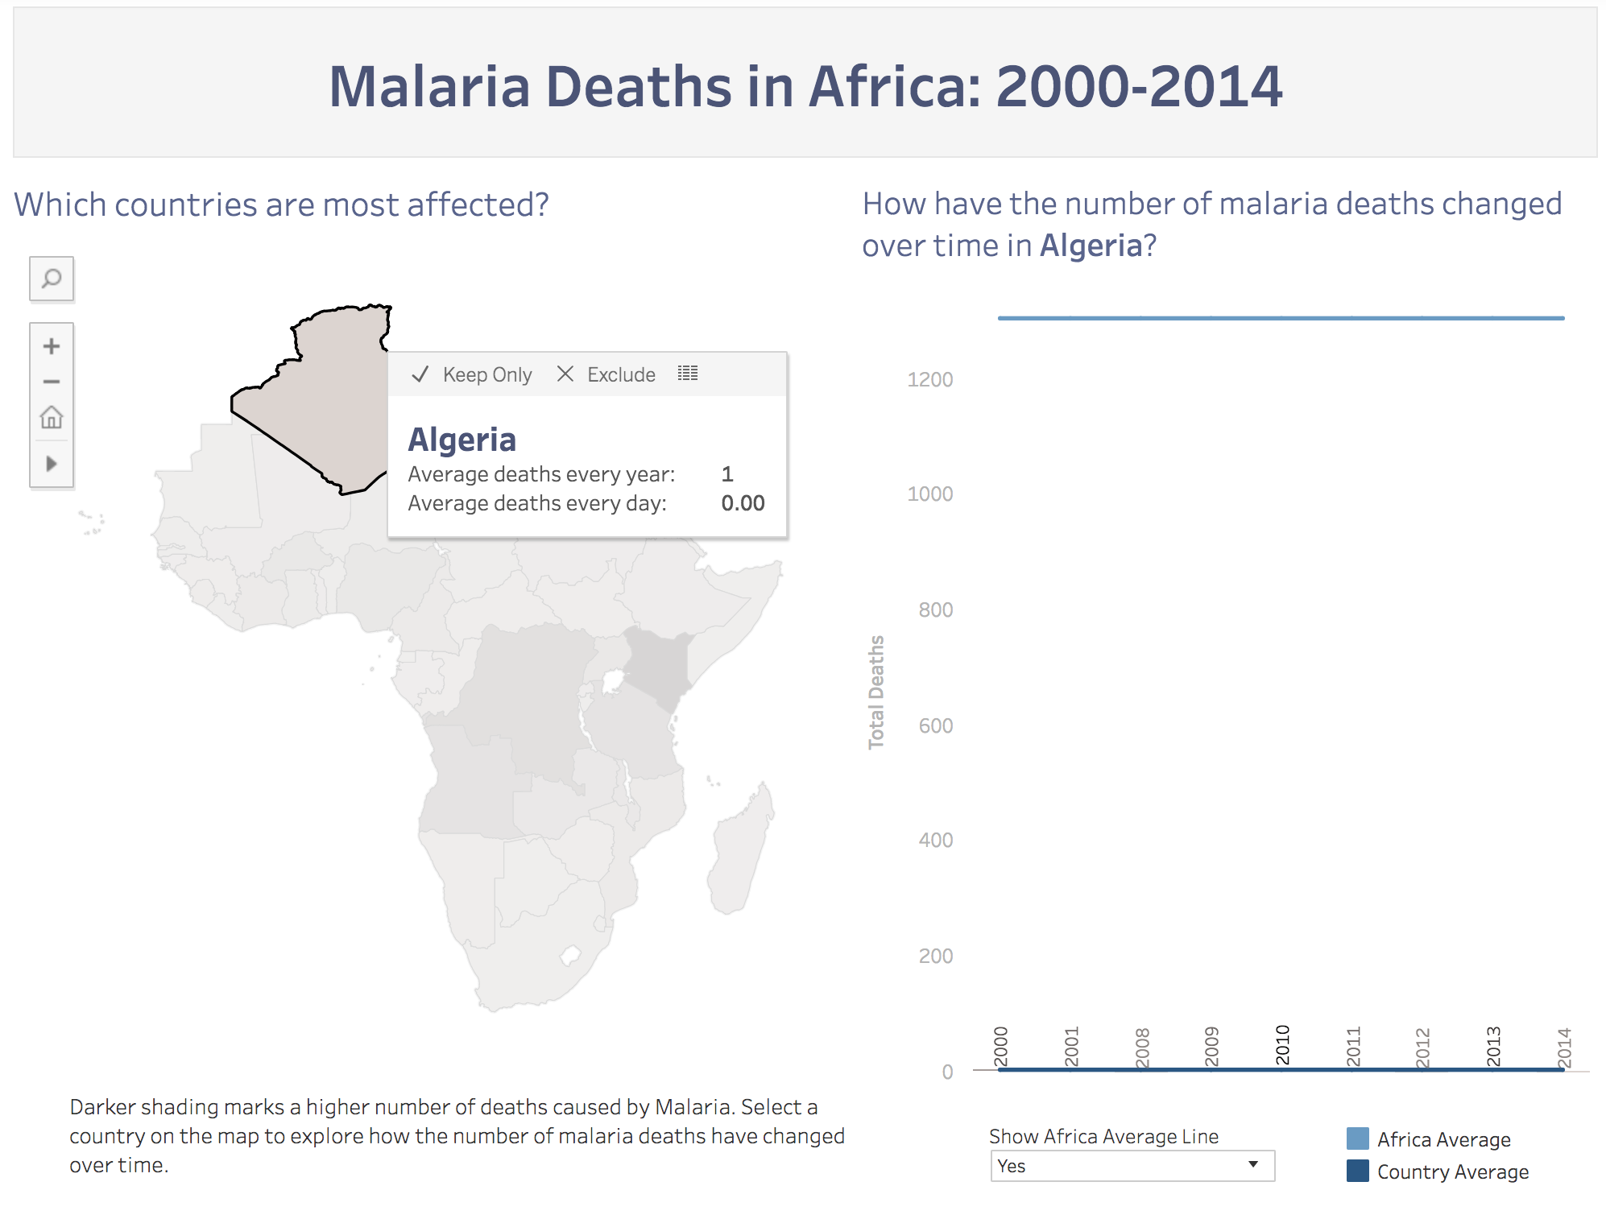
Insight 2:
Review data from the nearest Algeria's neighbor - Niger on the map it says that the highest death level was in 2010 around 4000 deaths due to malaria and the lowest in 2006 was around 1200 deaths due to malaria. GPR index in 2010 was equal to 328$ per year and in 2006 was 258$ per year.

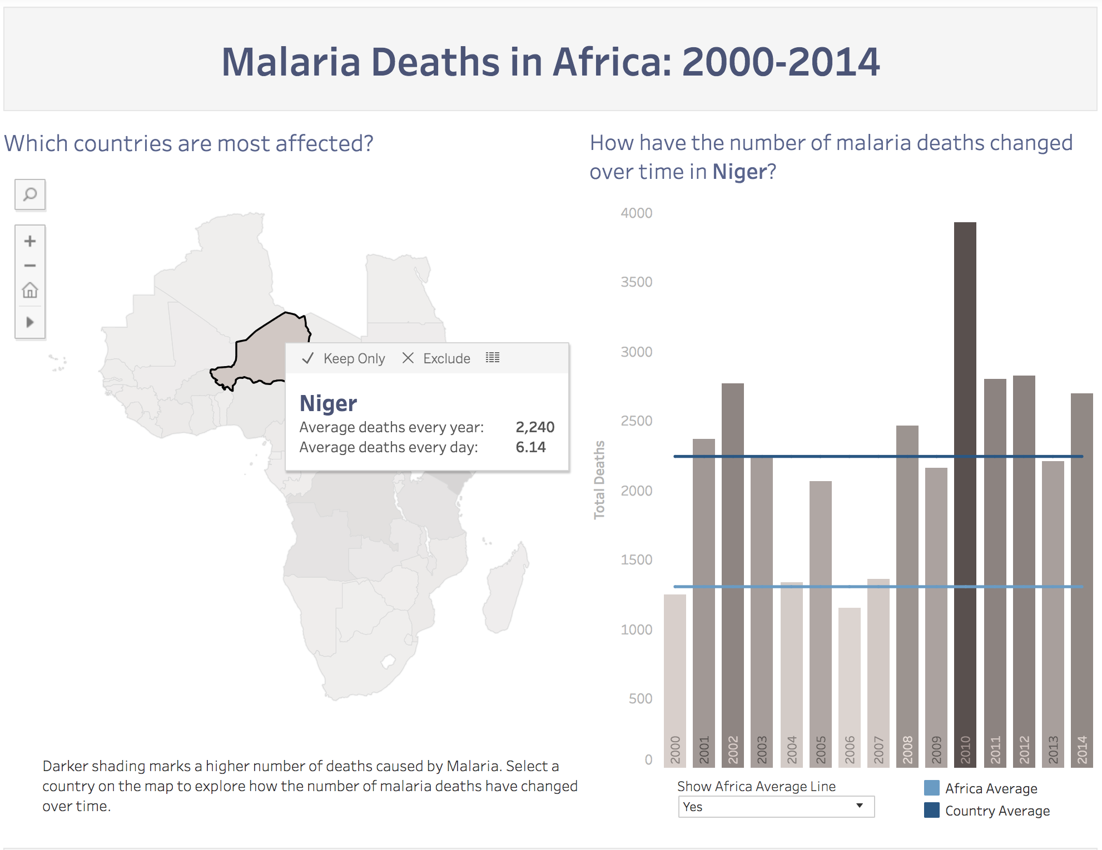

Insight 3:
Death level per year due to malaria in Kenya has the largest average compare to other countries in Africa and equal to 27,856. Before 2007, there were more then 1200 deaths per year. After 2007 Kenya experienced a decrease death level due to malaria. GDP index increased from 2007 year.

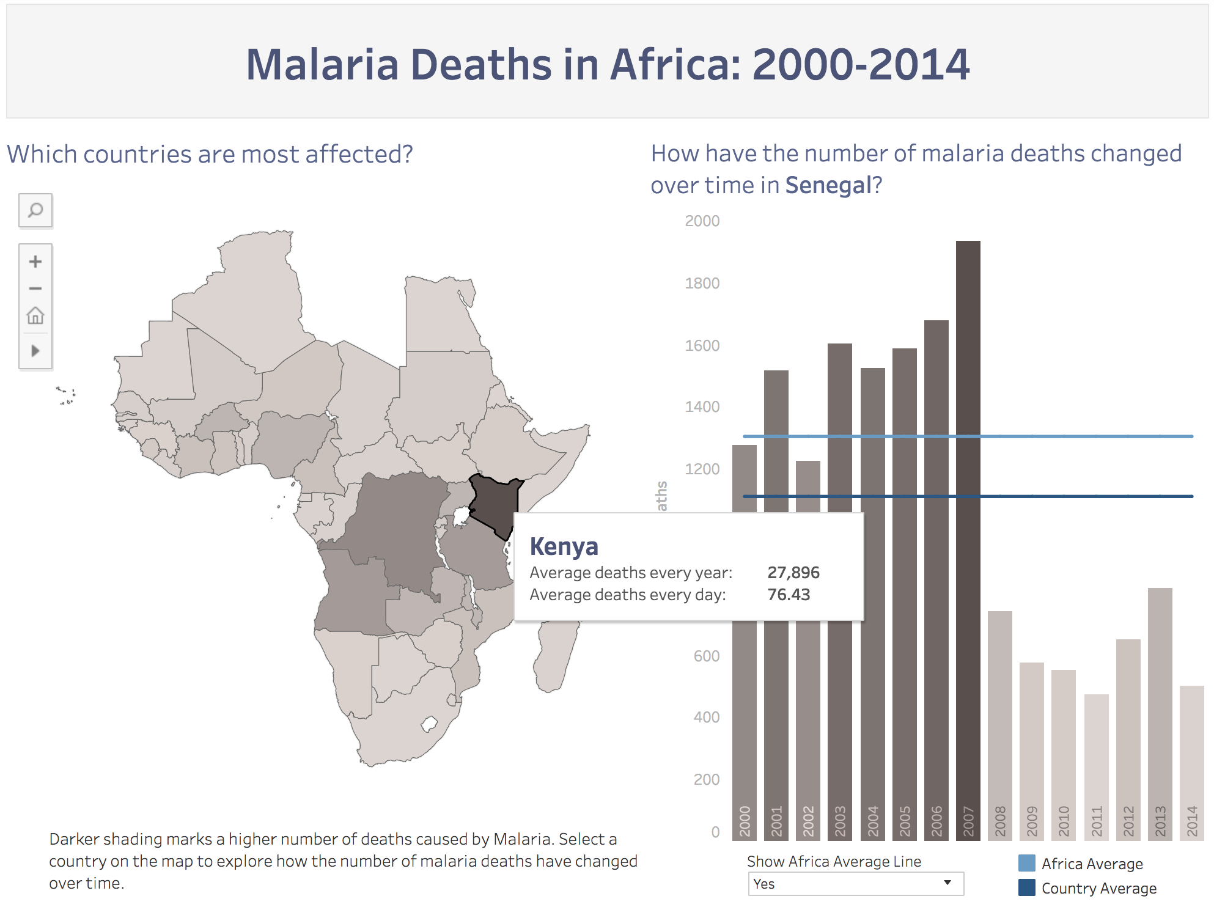

Conclusion:
We might say that we have noticed an inverse correlation or negative correlation between deaths per year due to malaria and GPR country index per year.

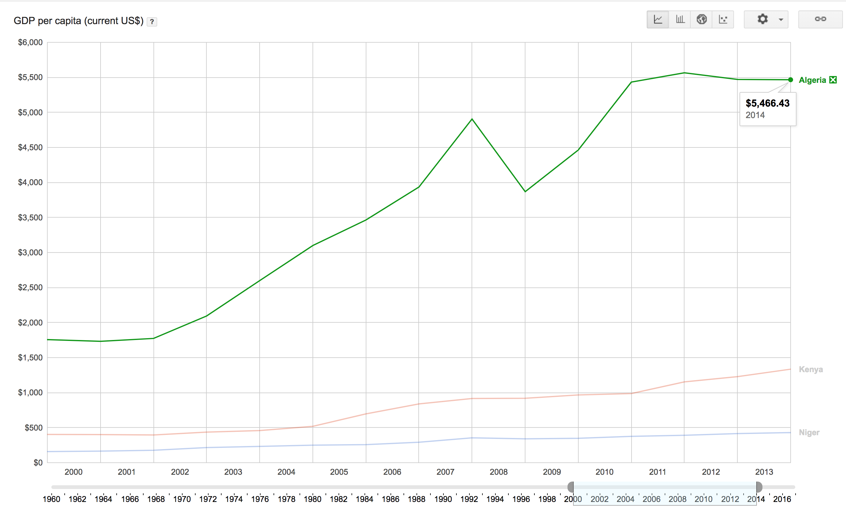
Country | GDP (2014 year in dollars) | Avg. number of death every year
Algeria | 5466.43 | 1
Niger | 429.79 | 2240
Kenya | 1335.12 | 27896

